|  |
| --- |
|  |

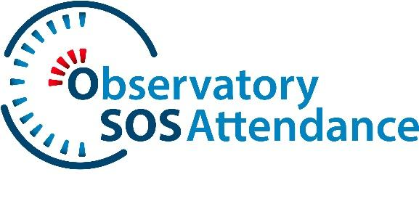

**SOS-ATTENDANCE POSTER COMPETITION**

**Awareness campaign about School Attendance Problems**

**OFFICIAL RULES AND GUIDELINES**

1. **Introduction**

The SOS-Attendance Poster Competition is an initiative of the European project SOS-Attendance, aimed at raising awareness about school attendance issues and early school leaving. This competition invites students and professionals in education and related fields to create a digital poster that conveys a clear and impactful message to combat these problems.

1. **Eligibility**

* The competition is open to two categories:
  + **Students** (Secondary)
  + **Professionals** (Teachers, educators, and professionals in related fields)
* Participants can enter individually.
* Each participant can submit only one poster.

1. **Theme**

Posters must focus on addressing school attendance problems and early school leaving, with a clear and concise message that promotes awareness and solutions.

1. **Submission Guidelines**

* Posters must be original and submitted digitally.
* Accepted formats: PNG, JPG, or PDF (Size DIN A3).
* The message should be in Spanish (or in another official language of the Spanish state), Italian or Turkish.
* Posters must not contain offensive, discriminatory, or inappropriate content.
* Submissions must be uploaded via the official competition website.

1. **Copyright and Usage Rights**

* By participating, entrants grant the SOS-Attendance Observatory the non-exclusive, royalty-free right to use, reproduce, and distribute their posters for non-commercial purposes.
* Posters may be used on the Observatory's website, social media, events, and awareness campaigns.
* The participant retains ownership of their work but agrees to its dissemination as part of the SOS-Attendance initiative.

1. **Judging Criteria**

A jury composed of experts in Education, Psychology, Design, and Communication will evaluate entries based on:

* Relevance to the theme (40%)
* Creativity and originality (30%)
* Visual impact and clarity of message (20%)
* Technical quality (10%)

1. **Awards**

* One winner per category (Students & Professionals) in each participating country.
* Winners will receive a **tablet and a certificate of recognition**.
* Honorable mentions may be awarded at the jury’s discretion.

1. **Timeline**

* **Submission Period:** March 1, 2025 – May 31, 2025
* **Winners Announcement:** June 13, 2025

1. **How to Enter**

* Visit <https://www.sosattendance.eu/en/awareness-campaign/mission> to complete the registration form and upload your submission.
* Ensure compliance with all submission guidelines before submitting.

1. **Contact Information**

For any inquiries, please contact: [info@sosattendance.eu](mailto:info@sosattendance.eu)

***By submitting an entry, participants confirm they have read and agreed to these rules.***